# Benefits of Using Python

Python is an interpreted, object-oriented, high-level programming language, built around the premise of Rapid Application Development. Several key and attractive Python features beneficial to our projects development are listed below.

* Descriptive error codes
* Plentiful online resources to aid in code development
* Language familiarity across the dev team
* High Level Language
* Presence of Third Party Modules

# Three Tier Pattern Justification

Due to the nature of our project, the ability to test code without requiring connections to a database via the use of a Three Tier Pattern will prove useful throughout the development phase. Out of the three architecture patterns available, our project fits best within the scope of a Three Tier design. Unlike Two-Tier, Three Tier Patterns allow the ability to test code without requiring a connection to a database. The ability to test code without requiring a connection to a database allows for easy isolation of the objects being tested. This ultimately allows for more efficient code and debugging practises to be made throughout the development cycle.

Furthermore, a project such as ours simply wouldn’t fit within the scope of a Two-Tier Pattern which combines User Interface alongside Business Logic. Our scope heavily relies on these two factors being independent, allowing many of the included features to properly function.

***Logical Software Architecture***

Logic Layer

Database Layer

Presentation layer

***Physical Software Architecture (Three Tier)***

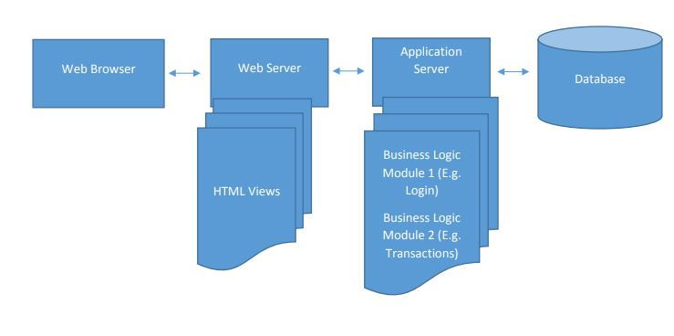

Website/Web Server

Modules: Account Functionality, Teacher/Admin control, etc.

***Data Flow Diagram(s)***

***Legend***

Entity

Process

Datastore

Music School Database

Create Account

***New/Logged Out User:***

This entity and its processes encompasses users new to the website or those who are not logged in.

Login

Teacher Applications

Apply for Teaching

Enrolment Data

Manage Lessons

***Logged In User:***

Encompasses students and teachers who are currently logged into the website.

Lesson Feedback

Account Page

Lesson Data

Music School Database

Edit Details

***Dataflow Diagram(s) Continued…***

Teacher Applications

Manage Applications

***Admin/Owner:***

This entity has special control over the system as well as its User. It’s account functionality includes all entities previously described. Similarly, this entity is able to read and write data at will

Music School Database

Current User(s) Information

Lesson Data

Manage Lesson Data

Music School Database

Account Management

***Component Diagram***

